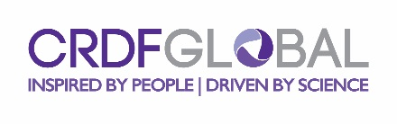
Project Public Summary
Public Summary: Please describe your project to a non-scientific community highlighting (in non-scientific language) the potential benefits that you expect your research to bring to your home university/institution, industry and the society at large. This should include a brief statement about the research problem you will attempt to solve; the importance of this problem to the scientific community; a description of specific applications of your research results and how they will contribute to solving the problem and/or furthering knowledge in the field. The public summary should be 200-300 words in length. Please do not re-submit the proposal abstract.

Sections below applicable for collaborative team projects only.
Team 1 Collaborators: [ENTER TEAM COUNTRY NAME]
Please describe the benefits of conducting your research in collaboration with your counterparts rather than independently (e.g. exchange of ideas, access to facilities, complimentary expertise, and access to new or unavailable data).

Team 2 Collaborators: [ENTER TEAM COUNTRY NAME]
Please describe the benefits of conducting your research in collaboration with your counterparts rather than independently (e.g. exchange of ideas, access to facilities, complimentary expertise, and access to new or unavailable data).

